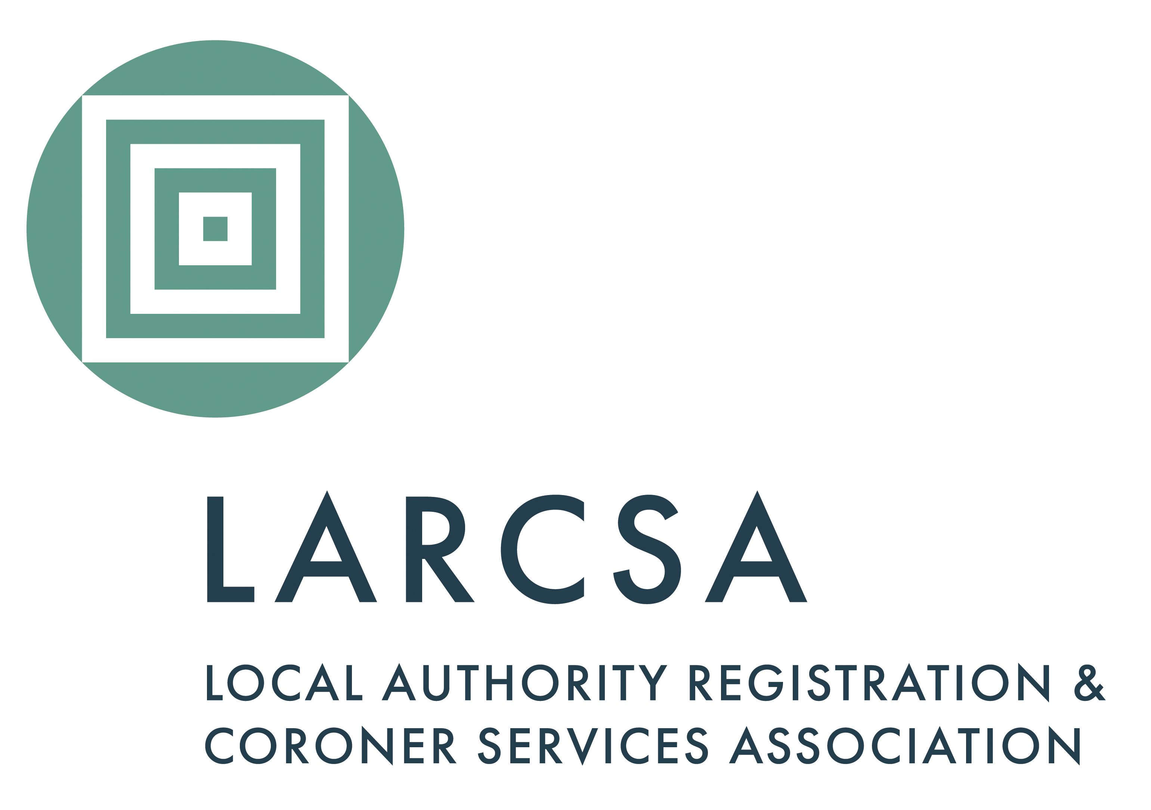
Local Authority Registration and Coroner Services Association
1 Sylvan Court, Sylvan Way

Southfields Business Park
Basildon, Essex SS15 6TH
Email: admin@larcsa.org.uk

Application for Membership 2026/27
£400 + VAT per annum for local authorities with a gross expenditure in excess of £600k. The subscription for Local Authorities with a gross expenditure of less than £600k is £300+VAT. The membership year runs from 1 April to 31 March. (Expenditure relates to the Registration Service).
Authority
Authority Address
General Office Contact Details
Address
Telephone number
Email address
Primary Contact
Name (including title)
Telephone number
Mobile number
Email address
Job Title
Second Contact
Name (including title)
Telephone number
Mobile number
Email address
Job Title
Third Contact
Name (including title)
Telephone number
Mobile number
Email address
Job Title
Please note: If there are more than three contacts that would like a log in to the LARCSA website, LARCSA can provide a general log in to all staff via a generic email address, supplied by you in the 'general office contact details' section.

Purchase order number
(Please be aware that your application will NOT be accepted without it)
Completed forms are to be returned to:
Email: | admin@larcsa.org.uk
Post: | LARCSA, 1 Sylvan Court, Sylvan Way, Southfields Business Park, Basildon, Essex, SS15 6TH

